IICS

# **Synchronization Task**

-Used to synchronize data between a source and a target

-Source or target can be of any type – flat file, database, salesforce, or from any valid connection

-can perform one of the following tasks – insert, update, upsert, delete

Upsert - cannot be done on a **flatfile** target

If record already present

Upsert

Insert

Update

Use case:

I have an orders list as a csv file in my system. I would like to synchronize this with the orders table in the Oracle database. Changes that take place in the csv file are:

New orders get added to the file

The status of orders get updated as – Shipped, Delivered

Log in to your IICS account, go to Data Integration.

Click New -> Task -> Synchronization Task

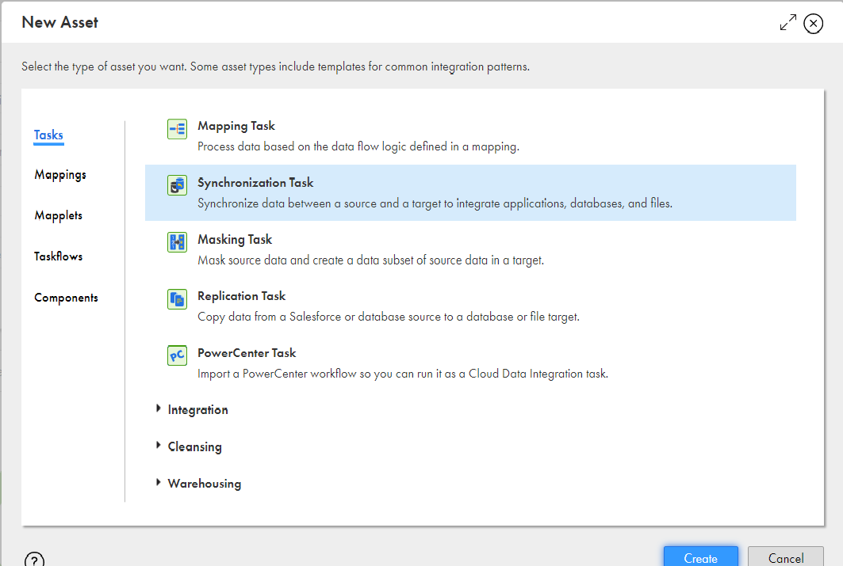

The Synchronization task wizard opens.

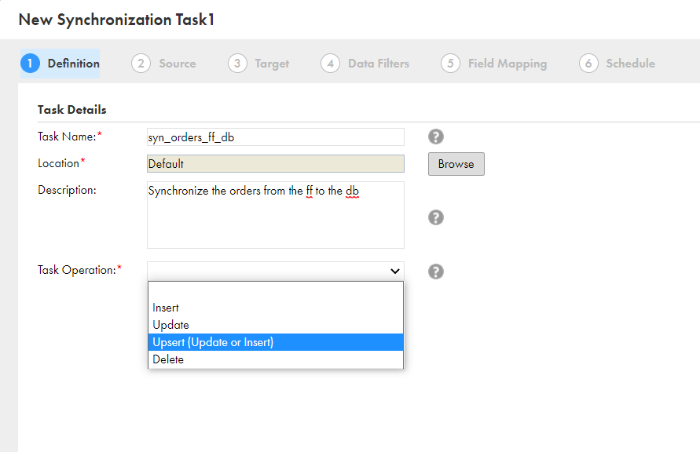

My source: Orders.csv – has the details of the orders that are placed.

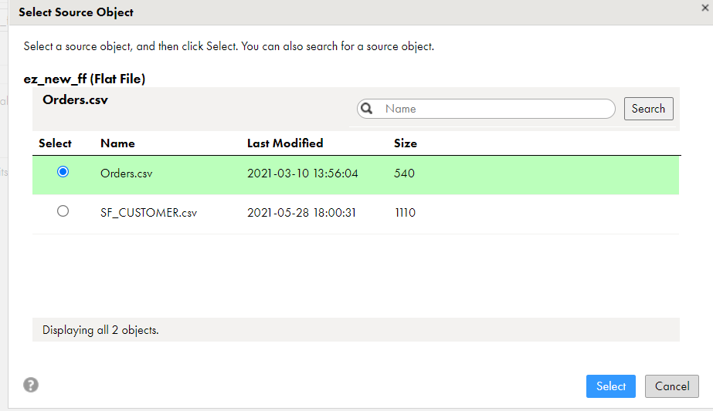

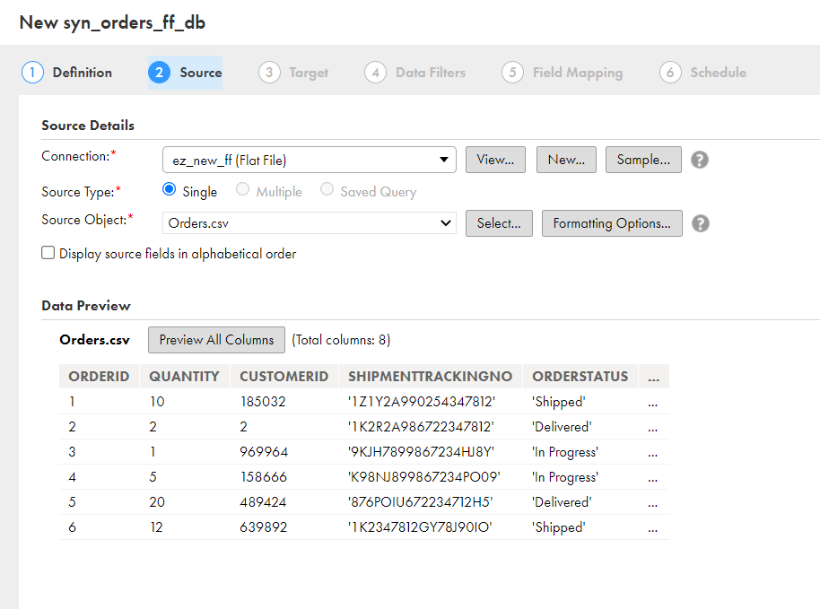

Target: I want to synchronize the orders.csv file to the ‘Orders’ table in the oracle database.

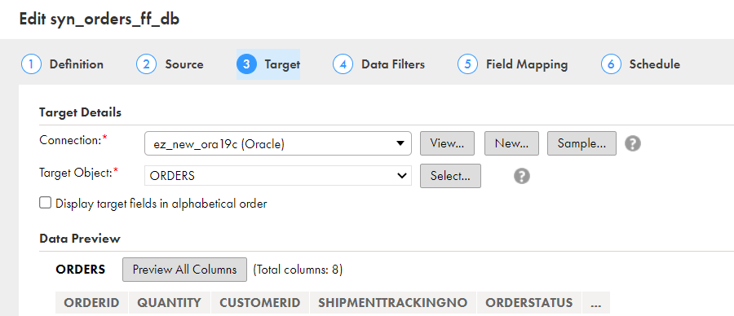

Data filters can you used to filter data according to the requirements. For example, I can filter only the orders that haven’t been delivered.

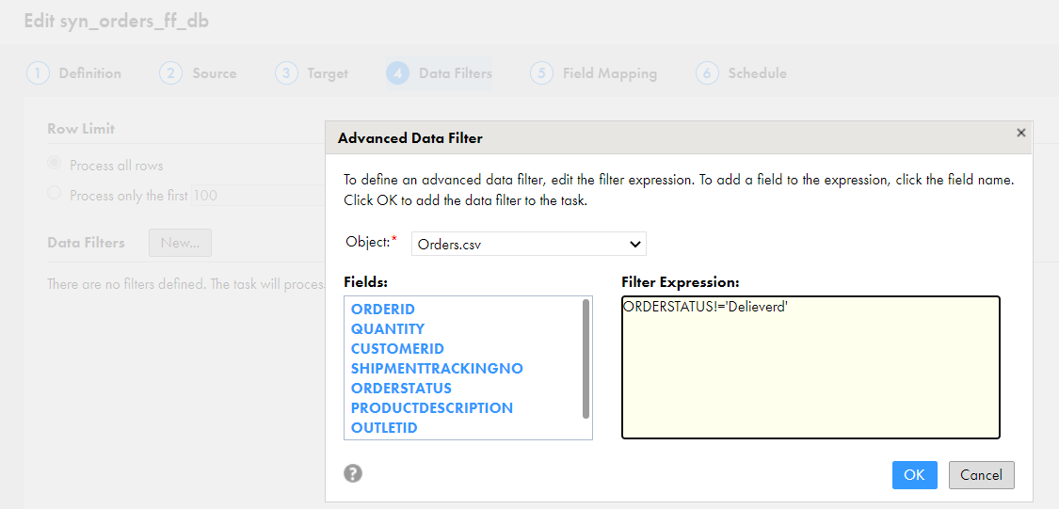

Expressions and lookups can also be used to transform the data and to fetch a value.

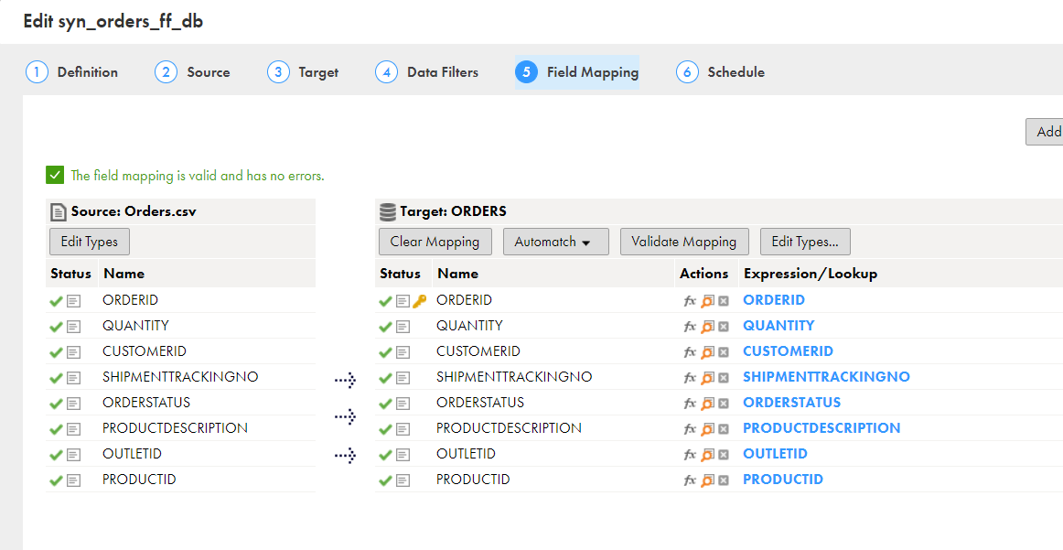

The synchronization task can be scheduled to run as per the business requirement.

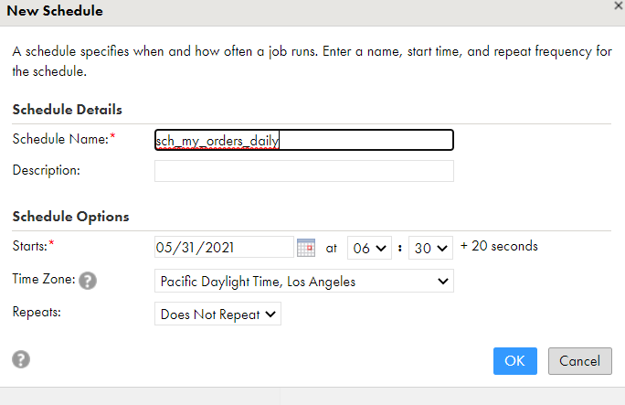

Save the synchronization task and run it. Job completed successfully.

Now the ‘orders’ table in the oracle database has been synchronized with my csv file.

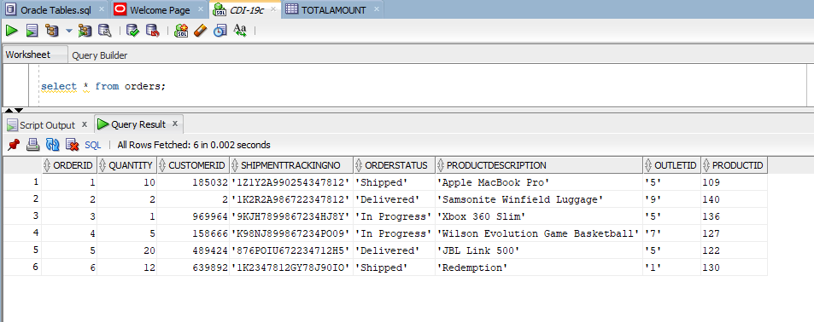

Now, I’ve made changes to my csv file.

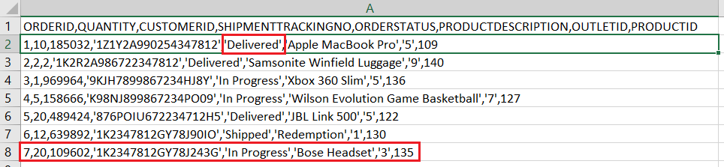

After running the synchronization task.

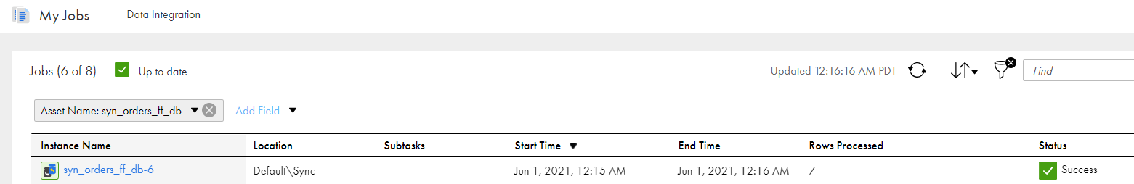

The changes ( update and insert- as I have chosen ‘upsert’) are reflected in the database.

